**BAB 4**

**DESKRIPSI PERANCANGAN PERANGKAT LUNAK**

**Sistem Antrean Klinik**

Dipersiapkan oleh:

Rezha Anugrah Hadi (1301150002)

Larasati (13011800098)

Ragiel Intan Haq (1301180206)

Dewa Made Aditya W. (1301180266)

Program Studi Informatika Fakultas Informatika

Jl. Telekomunikasi 1, Dayeuhkolot Bandung

|  |  |  |  |  |
| --- | --- | --- | --- | --- |
| https://lh6.googleusercontent.com/09saQW1u6HU6prMVes03dX-IPADV9m1E01aQK1LAyP4Ge3zHKxbgYy8zumKyL6Cd7PPo_M82LDVzMzOYWB4HDiwvZjnivDQXDTMRbIcgG_HfvJ8FJZH5JvKAVtnRum6ajpVCxHA | **Prodi S1- Informatika Universitas Telkom** | **Nomor Dokumen** | | **Halaman** |
| **DPPL BAB 4** | | *<#>/<jml #* |
| **Revisi** | *<nomor revisi>* |

1. **Perancangan Detil**
   1. **Perancangan Detil Kelas**

**TABEL KELAS :**

|  |  |  |  |
| --- | --- | --- | --- |
| **ID**  **Kelas** | **Nama Kelas Perancangan** | **Atribute (visibility)** | **Method / Operation** |
| 01 | Pasien | id_pasien : String (Public)  nama_pasien : String (Public)  data_antri : String (Public) | createdatapasien()  setnomor_antri() |
| 02 | Antrian | nomor_antrian : String (Public)  jenis_antri : String (Public)  pilihan_dokter : String (Public) | createdataantrian()  getid_pasien()  getid_dokter() |

**4.2. Perancangan Kelas Persistensi (***Basis Data Skema Tabel)**

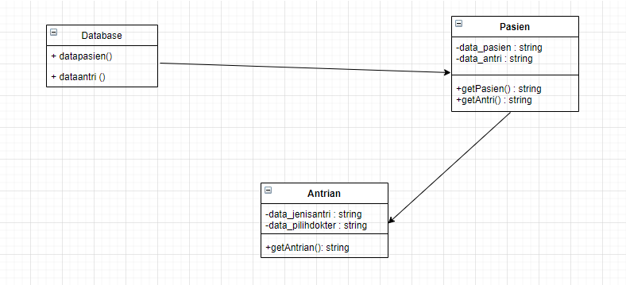

* + 1. **Algoritma**

Nama kelas : input antrian

Nama operasi : input antrian

Algoritma :

Begin:

Data_pilihdokter : string

Data_jenisantri : string

If (data_jenisantri = apotek) :

End.

Else (data_jenisantri = kesehatan) :

read(data_pilihdokter)

End.